Brute-Force String Matching

Basic Operation: Comparison
Best Case Time Complexity:
If the pattern is present in the 1st position of the text, then the number of comparisons made is equal to number of characters in the pattern.
.:Time complexity is given by,

Worst Case Time Complexity:
If all the characters of the pattern matches with the text expect the last character, the algorithm may have to make all m comparisons before shifting the pattern and this repeats for each of the n-m+1 tries.
ie. (P is not found or is found in the last m characters of T, so the outer for loop is executed n-m+1 times, and the inner loop is executed m times. 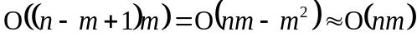)
The time complexity is given,

Average Case Time Complexity:
The average case efficiency should be considerably better then the worst-case efficiency. For searching in random texts, it has been shown to be linear.

